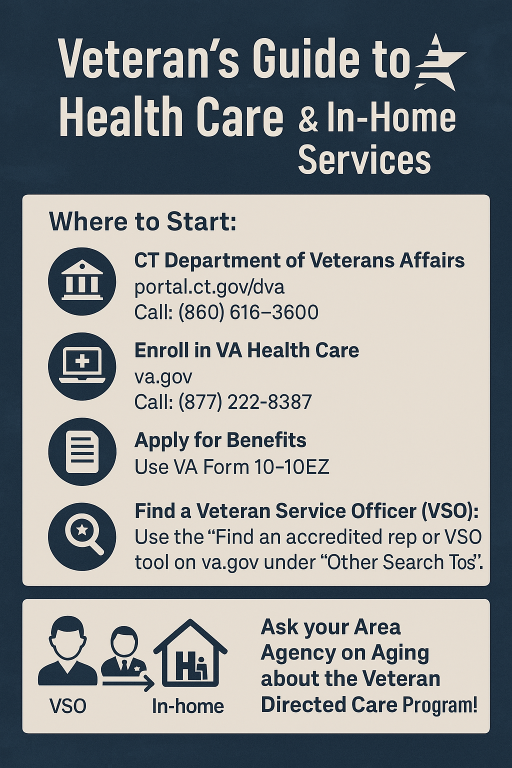

**Veteran’s Guide to Health Care**

How/Where to access health care, benefits, and in-home support and services:

* Department of Veteran Services Homepage:

<https://portal.ct.gov/dva>

OR call: (860) 616–3600 to speak to a State of CT benefits representative

* Enrolling in Health Care:

<https://www.va.gov>

OR call: (877) 222-8387

* Attached below is also a link for the VA Form 10-10EZ, which provides instructions and the application for health benefits:

[VA Form 10-10EZ](https://www.va.gov/vaforms/medical/pdf/VA_Form_10-10EZ.pdf)

When visiting the [VA.gov homepage](https://www.va.gov), scroll to the section titled “**Other search tools**” and click on **“Find an accredited rep or VSO”**. This feature allows veterans to locate a **Veteran Service Officer (VSO)**, who can assist with applying for benefits and determining eligibility. These officers are knowledgeable and accredited to help navigate the VA system.

**Veteran-Directed Care Program (VDC):**  
This is the primary veterans program supported by the **Area Agencies on Aging**. The VDC program allows veterans, or their authorized representatives, to **self-direct their home care services**. This means they have the flexibility to:

* Hire, train, and manage their own caregivers
* Choose trusted individuals (including family or friends, where permitted)
* Maintain control over who provides their care

All care planning, budgeting, and support services are managed in partnership with the Area Agency on Aging. Eligibility requirements must be met, and all caregivers must pass a background check.